ACSL
American Computer Science League
2013 - 2014

Contest #3

Intermediate Division

1.
- Graph Theory
Given the directed graph with vertices A, B, C, and D, and
directed edges AB, BD, CD, AC, CB, CA, DA, and AD.
Draw the adjacency matrix represented by the directed graph.

2.
- Graph Theory
How many paths of length 2 exist in the following directed graph?
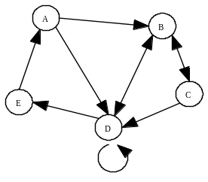

3.
- Boolean Algebra
Which ordered triple(s) make the following Boolean expression TRUE?
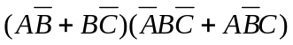

4.
- Boolean Algebra
How many ordered triples make this Boolean expression TRUE?
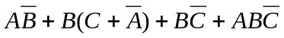

- What Does This Program Do?
How many of the entries are not zero after this program is run?
for a = 1 to 4
for b = 1 to 4
c(a,b)=a*b-2*a
next b
next a
for a = 1 to 4
for b = 1 to 4
if c(a,b)<0 then c(a,b)=0
if c(a,b)/2=int(c(a,b)/2) then c(a,b)=c(a,b)/2
if c(a,b) < 3 then c(a,b) = 0
next b
next a
end
5.

